1.Create an angular application with title as 'dropdown' in h1 tag.
Create a dropdown list which contains a list of product names.
when user clicks on the particular product, it should display the related details of that products. Display the output as shown in the expected screens

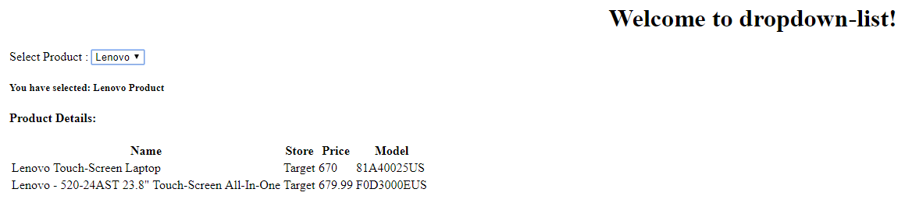

2. Create an Angular application with the title as "fileupload!" in h1 format.Create 2 buttons
1.Button1 for choose file with id Button1.
2.Button2 for upload the file with id Button2.(Disable the button until the file is selected)
If we click the choose file button it should open the libraries in your system.Choose the file or picture from library.
Enable the upload button.Click the upload button if it is uploaded then display as "100%" as a result with id as result.
Create another two buttons
1.Button3 for Hide files with id as Button3.
2.Button4 for show files with id as Button4.
After uploading the file if we click the showfiles button it should display the list of files selected from library and showfile button should change as Hidefiles Button
If we click the HideFiles Button the list of files should disappear.(Refer Screenshots)

3.Create an Angular application.Create another component as mainpage.
write the code to create a form with 2 textboxes
1.username with classname as name
2.password with classname as password and
3.Login button with the classname as button
The username and password should be "systemadmin" and "admin123" respectively.
If we click the button with the above username and password a alert box should appear with text "Login Successful" and direct to mainpage else a alert should appear with text "Invalid Login".
write a code in the mainpage to create a form with 4 textboxes
1.Firstname with classname as fname
2.Lastname with classname as lname
3.Address with classname as address
4.Phone No with classname as phoneno and
5.Submit button with classname as button
If we click the submit button the given details should displayed in table format with Proper Headings as given in screenshots.

4.Create an Angular application with Service and display "Welcome to Q7!" in h1 format and "Welcome" in paragraph format.

5.
Create an Angular application and create a new component as newcomponent.

6.Create an Angular application.Create a button as Ok with id as login
Clicking that button should display the text "The button has been clicked 2(count of button clicked) times." with the count of button clicked.
Refer the Screenshot.

7.Create an Angular application with the title as "Welcome to Task17!".Create two Buttons
1.Button as True with id button1
2.Button as False with id button2
If we Click the True button it should display the text as "Show this only if "show" is true".
If we Click the False button it should not display the above givem text.(Using ngIF)

8.Create an Angular application with the title as "Welcome to Task18!" in h1 format.Create One textbox and one button
1.Textbox with classname as fortextbox
2.Button with classname as button
Find whether the given input has only alphabets or it has numbers and special characters.
1.Given a String input for example sachin should display the text "The String contains only alphabets".
2.Given a String input for example sachin12 should display the text "The number or special Character is present".
3.If we doesnt give any input in the textbox it should show "Type Something in the textbox".

9.Create an Angular application with title as "Welcome to Task19!" in h1 format.Create a form with one textbox and oen button
1.Textbox with classname as fortextbox
2.Button with classname as button
Find the number of vowels in the given String in the textbox.(refer Screenshot)

10.Create an Angular application with the title "Welcome to Task20!" in h1 format.Create a form with two textboxes and one button
1.Textbox1 with classname fortextbox
2.Textbox2 with classname fortextbox1
3.Button with classname button
Find wthether the Substring(Text given in Textbox2) present in String given in Textbox1 if present display "true" else "false".

11.Create an Angular application with the title as "Welcome to Task21!" in h1 format.Create a form with two textboxes and a button
1.Textbox1 with classname as fortextbox.
2.Textbox2 with classname as fortextbox1
3.Button with classname as button
Find the difference between the two dates given as input for textbox1 and textbox2.(Refer Screenshot)

12.
Create an angular application with title as 'task22' in h1 tag.
Create two textboxes with id as textbox1 and textbox2 respectively.
Create two buttons with id as button1 and button2 and show the result as in expected screens.

